Task No 01: Print Fibonacci series ( 0,1,1,2,3,5,8…) by using for and while loop.
Input:
using System;

namespace Abdullah_Sadiq_CP_Home_Tasks
{
class Program
{
static void Main(string[] args)
{
Console.WriteLine("\t-Fibonacci series-");
Console.Write("\n n = ");
int n = int.Parse(Console.ReadLine());
int a = 0;
int b = 1;
int c = 0;
Console.Write("The Series is 0,1,");
while (n > 0)
{
c = a + b;
Console.Write(c + ",");
a = b;
b = c;
n--;
}
}
}
}

Output:
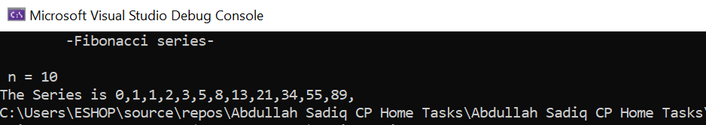
Task No 02: Repeatedly print the value of the variable x Value, decreasing it by 0.5 each time, as long as x Value remains positive. (while loop)
Input:
static void Main(string[] args)
{
double i;
Console.Write("Enter the Value of x: ");
i = Convert.ToDouble(Console.ReadLine());
while (i >0)
{
Console.WriteLine("{0,-5:0.0}- 0.5 = {1,-5:0.0}", i, i -= 0.5);
}
}
Output:

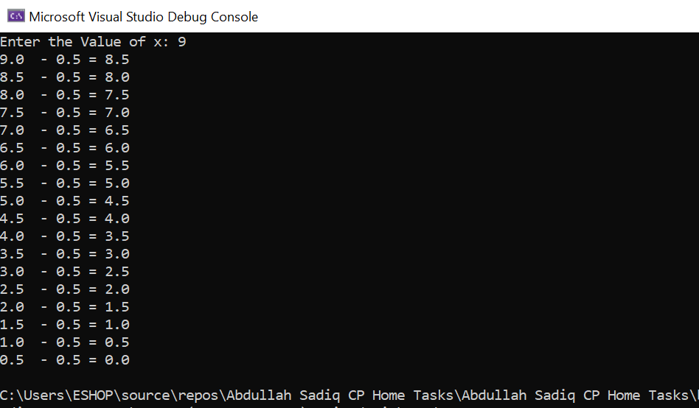
Task No 03: Print the square roots of the first 25 odd positive integers.
Input:
using System;

namespace Abdullah_Sadiq_CP_Home_Tasks
{
class Program
{
static void Main(string[] args)
{
int n = 1;
Console.WriteLine("\t-The square roots of the first 25 odd positive integers-");
while (n < 51)
{
double root = Math.Sqrt(n);
Console.WriteLine("The Square Root of {0,-2:0} is: {1,-5:0.00}", n, root);
n += 2;
}
}
}
}

Output:
